Honest Abe’s Almanac: The Wit and Wisdom of Abraham Lincoln
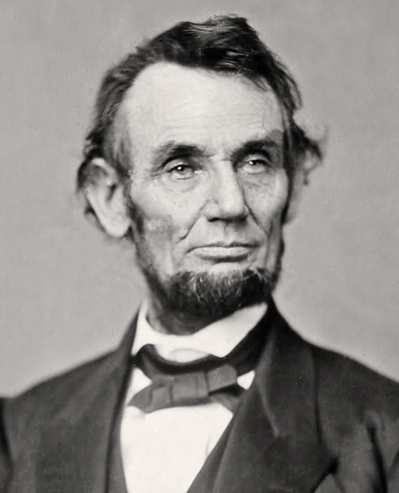
Teacher’s Guide

- Write out the quote you are going to research:

- Identify the writing in which Lincoln used the words.

- Explain context for that document – when and why was it written?

- Apply Lincoln's ideas to the present day. What issues does he discuss that are still issues currently facing the United States?

- Examine Lincoln's words in one of the categories. Formulate a one to two sentence summary of his ideas and thoughts on the given subject.

- Devise a list of the top five most important pieces of advice Lincoln gave. Justify your choices.

- Evaluate Lincoln’s advice for the present day. How can you apply his words to your own life?

- Finally, what is one question you would ask Abraham Lincoln after reading his words? Why did you choose that question?
Copyright 2016 Adam Sonstroem. May be used and adapted as long as proper credit given to the source.

